HEATWAVE DATA CLEANING

* Use of conditional formatting in excel to compare and Delete duplicate countries

* Correction of Country names that are wrongly spelt

* The use of pivot table to determine the number of countries and their status count before and after cleaning

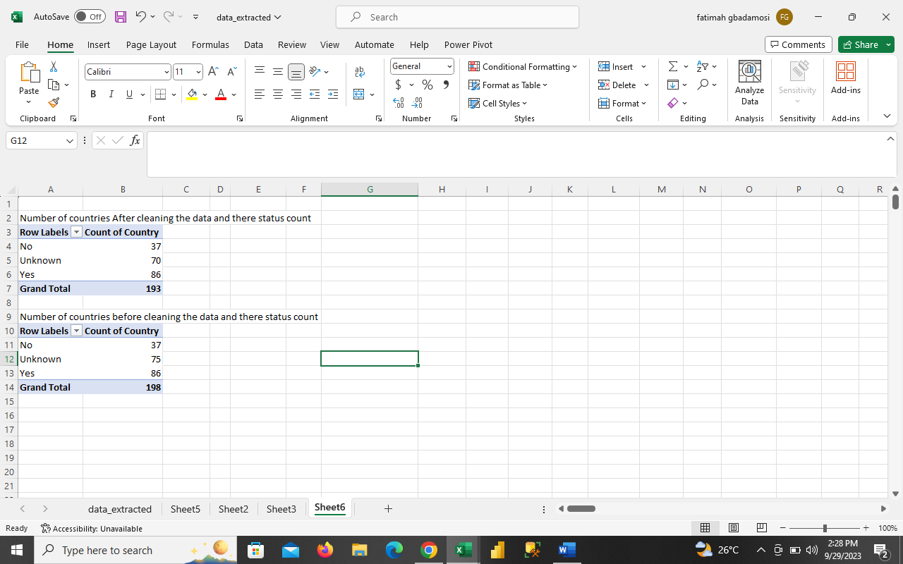

* Ensured that there is no duplicates in the data sets and title of colum D and E was modified

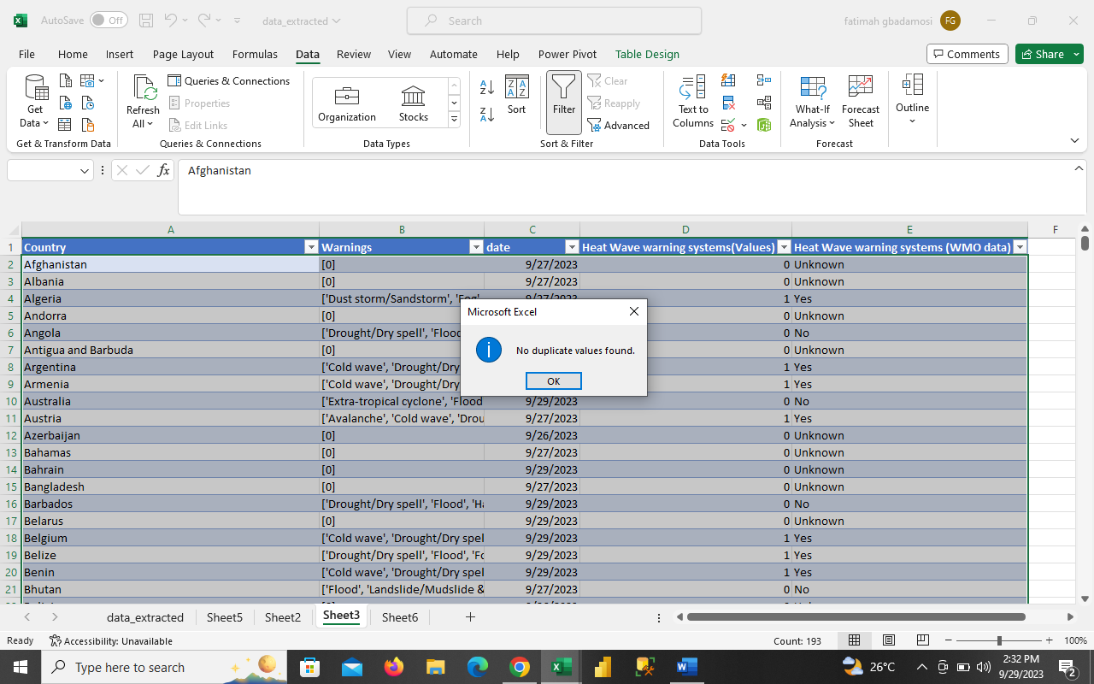

OBSERVATIONS

* After cleaning the data, the total number of countries for the old and new data sets are the same
* Colum A and E are the same datas; YES =1 while NO and UNKNOWN = 0
* UNKNOWN data in column E of new data is same as N/A in column B of old data

DISCUSSION

* Meeting between Cynthia and Fatimah Whether to delete column B in new data or use it